INSTRUCTIONS FOR COMPLETING THIS DOCUMENT
- This Statutory Declaration forms the basis of your application for certification. To avoid any delays, it is important that each section of this document is completed accurately. Please read the following details carefully, failure to provide the necessary information will result in this document being returned for additional information.
- To minimise delays with your application please ensure this document and any attached information is either typed or printed in black or blue pen CLEARLY in CAPITAL LETTERS.
- If certification is required for more than one property, on separate titles or under separate management systems, a Statutory Declaration must be completed for each property.
- All questions must be answered, write N/A, nil or none if not applicable.
- This document must be signed on each page and where indicated before a Witness (as specified in the Eligible Witness List). Please note: family members are ineligible to witness.
- Within one month of receipt of this document:
- An ACO authorised auditor will make an appointment to visit your property for an evaluation for certification. This first audit of your property should occur within the first three months from your application – unless you have elected for the fast track payment option.
- Sample/s of soil and/or tissue may be taken for chemical residue testing at either this first or subsequent audit.
- The auditor’s report is forwarded to the Certification Review Committee, which analyses all factors relating to organic production. The applicant will be advised of the outcome of the certification review within 6 weeks of the first audit occurring, unless there are mitigating circumstances.

CHECKLIST  MUST BE COMPLETED PRIOR TO POSTING YOUR APPLICATION. THIS WILL ASSIST IN THE APPRAISAL OF YOUR APPLICATION | TICK WHEN COMPLETE
All sections of the Statutory Declaration have either been answered or marked NA
This Statutory Declaration has been initialled and dated at the bottom of every page by the client, in the presence of the witness (as specified in the Eligible Witness List at the end of this document) who has also initialled and dated the bottom of every page. Please note: family members are ineligible to witness.
Additionally, the client and witness have printed their names, signed in full and dated this Statutory Declaration where indicated in the boxed section.
Required appendices are attached (Appendix 1-5)

1. LICENSEE(S) DETAILS
GIVEN NAMES: |  |  | TRADING NAME:
SURNAME:
PROPERTY ADDRESS
ADDRESS 1:
ADDRESS 2:
SUBURB or TOWN: |  |  | POSTCODE:
STATE: |  |  | COUNTRY:

I BEING THE PERSON RESPONSIBLE FOR THIS DECLARATION (HEREIN REFERRED TO AS THE OPERATOR) DO SOLEMNLY AND SINCERELY DECLARE:
2. OPERATION DETAILS
ABN: |  |  | TICK APPLICABLE | Company
ARBN: |  |  |  | Partnership
 |  |  |  | Sole Operator
 |  |  |  | Public Company
 |  |  |  | Trust

3. POSITION DETAILS
TICK APPLICABLE | Sole Owner |  |  | Director
 | Co-owner |  |  | Manager
 | Employee |  |  | Secretary
 | Sharefarmer |  |  | Shareholder
 | Partner |  |  | Consultant
 | Other (PLEASE SPECIFY)

4. CONTACT DETAILS
TELEPHONE (W): |  |  | TELEPHONE (AH):
MOBILE: |  |  | EMAIL:

5. REAL PROPERTY DESCRIPTION (REFER TITLE DEED/RATES NOTICE)
LOT NO: |  |  | AREA: | (acres/hectares)
HUNDRED: |  |  | COUNTY:
PARISH: |  |  | SHIRE:
LOCATION |  |  | STATE:

IF MORE THAN ONE PROPERTY, PLEASE ATTACH ADDITIONAL DETAILS
6. OWNERSHIP OF PROPERTY
THE PROPERTY HAS BEEN IN THE CONTROL OF THE OPERATOR SINCE:

7. LEASE OR SHAREFARM

IS THIS PROPERTY LEASED OR SHAREFARMED? (please tick)
No (Go to Q8)
Yes (If yes, please provide details below, and attach a completed Lease Agreement)

IF LEASED OR SHAREFARMED, THE OWNER’S DETAILS
Owners Name |  |  |  | Street Address
Telephone: |  |  |  | Address 2
Email: |  |  |  | Suburb/Town
 |  |  |  | Country |  | PC

8. MEMBERSHIP/CERTIFICATION

HAVE YOU OR YOUR ORGANISATION EVER BEEN REFUSED MEMBERSHIP OF, OR HAD CERTIFICATION WITHDRAWN/DENIED/DECERTIFIED, BY ANY CERTIFYING ORGANIC OR BIODYNAMIC ORGANISATIONS? (please tick)
No
Yes (If yes, please provide details)

ARE YOU CURRENTLY CERTIFIED WITH ANY OTHER CERTIFYING BODIES? (please tick)
No
Yes (please provide details below)

STATEMENTS 9-14 RELATE TO YOUR ENTIRE PROPERTY, WHETHER SEEKING FULL CERTIFICATION OR NOT

9. ENTIRE PROPERTY AREA

THE ENTIRE AREA OF THE PROPERTY IS:
Property Area: | HECTARES ONLY

10. ENTIRE PROPERTY COMPOSITION

ARABLE and NON-ARABLE LAND:
Arable Land: | HECTARES ONLY |  | Non-Arable Land: | HECTARES ONLY

CONSISTING of:
Native Vegetation: | HECTARES ONLY |  | Irrigated: | HECTARES ONLY
Horticulture : | HECTARES ONLY |  | Broadacre: | HECTARES ONLY
Tree crops/ Vines: | HECTARES ONLY |  | Grazing/Pastoral: | HECTARES ONLY

SOIL TYPE AVERAGE RAINFALL:
Soil Type: |  |  | Avg Rainfall:

11. AREA SEEKING CERTIFICATION

ACO CERTIFICATION IS REQUESTED ON: (please tick)
Part Property (please provide details below)
Whole Property (Go to Q12)

THE AREA OF THE PROPERTY SEEKING CERTIFICATION:
Property Area: | HECTARES ONLY

REASON WHY WHOLE PROPERTY IS NOT TO BE CERTIFIED:

Please explain why whole property is not to be certified:

DESCRIPTION OF FARMING PRACTICES ON AREA/S NOT SEEKING CERTIFICATION:

Please provide a brief description of farming practices on area/s not seeking certification:

12. PRODUCTS

I HEREBY APPLY FOR ACO CERTIFICATION FOR THE FOLLOWING PRODUCTS:
Product 1 |  |  | Product 7
Product 2 |  |  | Product 8
Product 3 |  |  | Product 9
Product 4 |  |  | Product 10
Product 5 |  |  | Product 11
Product 6 |  |  | Product 12

13. CONSULTANTS

DO YOU USE CONSULTANTS? (please tick)
No
Yes (please provide details below)

CONSULTANTS DETAILS
Please provide details on the services they provide: |  | Street Address
 |  | Address 2
 |  | Suburb/Town
 |  | Country |  | PC

14. LIVESTOCK

DO YOU HAVE LIVESTOCK? (please tick)
No (Go to Q16)
Yes (please provide details below)

THE AVERAGE NUMBERS OF LIVESTOCK CARRIED IS:
Sheep: |  |  | Poultry:
Cattle |  |  | Others

WILL THESE LIVESTOCK HAVE ACCESS TO CERTIFIED / TO BE CERTIFIED AREAS? (please tick)
No
Yes

WILL THESE LIVESTOCK BE MANAGED ORGANICALLY AS SPECIFIED IN THE RELEVANT STANDARD/S? (please tick)
No (please provide details below)
Yes

Please explain reason why these livestock are not to be included in certification:

15. ORGANIC LIVESTOCK MANAGEMENT

BREEDING METHODS OF ORGANICALLY MANAGED LIVESTOCK:

Please explain breeding methods:

REPLACEMENT STOCK AND SOURCE OF ORGANICALLY MANAGED LIVESTOCK:

Please explain replacement stock and source:

16. CONVENTIONAL/NON-ORGANIC PRODUCTION

CONVENTIONAL PRODUCTION:
CROP TYPE | EST. PRODUCTION NEXT 12 MONTHS

STATEMENTS 17-20 RELATE TO THE AREAS FOR WHICH CERTIFICATION IS SOUGHT.

17. SOIL DEVELOPMENT TECHNIQUES

PROVIDE DETAILS OF SOIL DEVELOPMENT TECHNIQUES USED IN YOUR PRODUCTION SYSTEM:
i.e., green manuring, rotational cropping and grazing principles, mulching etc:

DO YOU COMPLETE REGULAR SOIL TESTING? (please tick)
No
Yes – how often

18. INPUTS HISTORY

IS THERE IS ANY KNOWN RESIDUAL OR PAST CHEMICAL HISTORY OF THE PROPERTY THAT MAY AFFECT CERTIFICATION: (please tick)
No
Yes (please provide details below)

KNOWN RESIDUAL OR PAST CHEMICAL HISTORY OF THE PROPERTY THAT MAY AFFECT CERTIFICATION:

Please detail:
WRITE DOWN ANY INPUTS (INCLUDING FERTILISERS, COMPOST, MICRONUTRIENTS, SOIL AMENDMENT, PEST CONTROL, WEED CONTROL, FUNGICIDE ETC) USED OVER THE PAST THREE (3) YEARS OF THE PROPERTY’S HISTORY.
(If more space is required, please append extra sheets.)
PRODUCT NAME | TYPE | NATURAL/ SYNTHETIC | RATE/ HA | PADDOCK AREA NAME / NUMBER | AREA COVERED | MONTH | YEAR
PRODUCT NAME | TYPE | NATURAL/ SYNTHETIC | RATE/ HA | PADDOCK AREA NAME / NUMBER | AREA COVERED | MONTH | YEAR
LIVESTOCK N/A (please tick this box if you don’t have livestock) – GO TO Q21

19. PARASITE CONTROL
WRITE DOWN ANY PARASITE CONTOROL (BOTH SYNTHETIC AND NATURAL) FOR LIVESTOCK USED OVER THE PAST THREE (3) YEARS OF THE PROPERTY’S HISTORY.

PRODUCT | NATURAL/ SYNTHETIC | FOR CONTROL OF | AGE OF STOCK | INTERNAL/ EXTERNAL | MONTH | YEAR

20. OTHER PRODUCTS USED
Write down other products (i.e., growth inhibitors, promotants, antibiotics, vaccines etc) used and how long they have been used.

21. CONTRACTORS

I / WE HAVE USED CONTRACTORS: (please tick)
No
Yes (complete details below)

CONTRACTORS USED:
CONTRACTOR NAME | JOB | MONTH | YEAR

22. STORAGE METHODS

STORAGE METHODS ON OR OFF-FARM OF PRODUCTS SEEKING CERTIFICATION ARE AS FOLLOWS:

Please explain:

23. OFFSITE PROCESS DETAILS

OUR PRODUCTS ARE STORED/CLEANED/PROCESSED OFF THE PROPERTY BEFORE FINAL SALE: (please tick)
No
Yes (please provide details below)

OFFSITE DETAILS
PROCESS |  |  |  |  |  | PROCESS
Address 1 |  |  |  |  |  | Street Address
Address 2 |  |  |  |  |  | Address 2
Suburb/Town |  |  |  |  |  | Suburb/Town
Country |  | PC |  |  |  | Country |  | PC

24. DECLARATION

A. I UNDERSTAND SOIL, PLANT, OR PRODUCT TESTING WILL BE REQUIRED AT MY EXPENSE, AND THAT FURTHER TESTING MAY BE REQUIRED AT FUTURE DATES: (please tick)
No
Yes

B. I UNDERSTAND THAT REGULAR SAMPLES OF MY/OUR PRODUCE WILL BE SUBJECT TO A RANDOM CHEMICAL RESIDUE TEST AND COULD BE AT MY OWN EXPENSE WHERE IT CANNOT BE VERIFIED THAT CONTAMINATION DID NOT OTHERWISE ARISE FROM ON-FARM PRACTICES: (please tick)
No
Yes

C. I HAVE READ AND UNDERSTOOD THE CURRENT VERSION OF THE RELEVANT STANDARD/S TO WHICH CERTIFICATION IS SOUGHT, AND WILL COMPLY WITH ALL RELEVANT PROVISIONS OF THE CERTIFICATION PROGRAMS: (please tick)
No
Yes

D. I ACKNOWLEDGE THIS DECLARATION IS MADE WITH A CLEAR UNDERSTANDING OF THE REQUIREMENTS SET OUT IN THE RELEVANT STANDARD/S: (please tick)
No
Yes

E. I ACKNOWLEDGE THAT KEEPING COMPREHENSIVE RECORDS OF PRODUCTION ACTIVITIES AND SALES, AS SPECIFIED IN THE RELEVANT STANDARD/S, IS A KEY ASPECT OF ATTAINING AND MAINTAINING CERTIFICATION: (please tick)
No
Yes

F. I ACKNOWLEDGE THAT ANY DEPARTURE FROM THE PRINCIPLES OF THE RELEVANT STANDARD/S, MUST BE NOTIFIED IN WRITING TO THE ACO CERTIFICATION OFFICE: (please tick)
No
Yes

G. I / WE ARE AWARE I/WE WILL BE LIABLE FOR PENALTIES APPLICABLE TO THE RELEVANT STATE FOR ANY WILFULLY MADE FALSE STATEMENT: (please tick)
No
Yes

H. I DO SINCERELY DECLARE THAT THE STATEMENTS MADE IN THIS APPLICATION ARE TRUE AND CORRECT TO THE BEST OF MY KNOWLEDGE AND BELIEF: (please tick)
No
Yes

SIGNED:
 | Print Full Name Clearly |  | Signature |  | Date
WITNESSED BY:
 | Print Full Name Clearly |  | Signature |  | Date
ELIGIBLE WITNESS CATEGORY  (as per List below) | Please state profession

ALL PAGES MUST BE SIGNED, DATED AND WITNESSED (BY AUTHORISED WITNESS AS PER LIST BELOW), OTHERWISE DOCUMENT WILL BE RETURNED.
Family members are ineligible to witness documentation.
The following list details people that can witness a stat dec under the Statutory Declarations Regulations of 1993 which is bound by the Statutory Declarations Act of 1953 under Australian Commonwealth Law (does not differ to individual states)
A statutory declaration under the Statutory Declarations Act 1959 may be made before –
- a person who is currently licensed or registered under a law to practise in one of the following occupations:

Chiropractor | Dentist | Legal practitioner
Medical practitioner | Nurse Optometrist | Patent attorney
Pharmacist | Physiotherapist | Psychologist
Trademarks attorney | Veterinary surgeon

- a person who is enrolled on the role of the Supreme Court of a State or Territory, or the High Court of Australia, as a legal practitioner (however described); or
- a person who is in the following list:
- Agent of the Australian Postal Corporation who is in charge of an office supplying postal services to the public.
- Australian Consular Officer or Australian Diplomatic Officer (within the meaning of the Consular Fees Act 1955)
- Bailiff
- Bank officer with 5 or more continuous years of service
- Barrister
- Building society officer with 5 or more years of continuous service
- Chief executive officer of a Commonwealth court
- Clerk of a court
- Commissioner for Affidavits
- Credit union officer with 5 or more years of continuous service
- Employee of the Australian Trade Commission who is:
  - in a country or place outside Australia; and
  - authorised under paragraph 3 (d) of the Consular Fees Act 1955; and
  - exercising his or her function in that place
- Employee of the Commonwealth who is:
  - in a country or place outside Australia; and
  - authorised under paragraph 3 (c) of the Consular Fees Act 1955; and
  - exercising his or her function in that place
- Fellow of the National Tax Accountants’ Association
- Finance company officer with 5 or more years of continuous service
- Holder of a statutory office not specified in another item in this list
- Judge of a court
- Justice of the Peace
- Justice of the Peace (Commissioner for Declarations)
- Magistrate
- Marriage celebrant registered under Subdivision C of Division 1 of Part IV of the Marriage Act 1961
- Master of a court
- Member of Chartered Secretaries Australia
- Member of Engineers Australia, other than at the grade of student
- Member of the Association of Taxation and Management Accountants
- Member of the Australasian Institute of Mining and Metallurgy
- Member of the Australian Defence Force who is:
- an officer; or
- a non-commissioned officer within the meaning of the Defence Force Discipline Act 1982 with 5 or more years of continuous service; or
- a warrant officer within the meaning of that Act
- Member of the Institute of Chartered Accountants in Australia, the Australian Society of Certified Practising Accountants or the National Institute of Accountants
- Member of:
- the Parliament of the Commonwealth; or
- the Parliament of a State; or
- a Territory legislature; or
- a local government authority of a State or Territory
- Minister of religion registered under Subdivision A of Division 1 of Part IV of the Marriage Act 1961
- Notary public
- Permanent employee of the Australian Postal Corporation with 5 or more years of continuous service who is employed in an office supplying postal services to the public.
- Permanent employee of:
- the Commonwealth or a Commonwealth authority; or
- a State or Territory or a State or Territory authority; or
- a local government authority.
with 5 or more years of continuous service who is not specified in another item in this list.

- Person before whom a statutory declaration may be made under the law of the State or Territory in which the declaration is made
- Police officer
- Registrar, or Deputy Registrar, of a court
- Senior Executive Service employee of:
- the Commonwealth or a Commonwealth authority; or
- a State or Territory or a State or Territory authority
- Sheriff
- Sheriff’s officer
- Solicitor
- Teacher employed on a full-time basis at a school or tertiary education institution

APPENDICES
(PLEASE ATTACH THE FOLLOWING DOCUMENTS TO SUBMIT WITH THIS STATUTORY DECLARATION)
FARM MAP  A sample farm map is attached. All requested details must be included. It is preferred the farm plan is completed on A4 size paper as a copy is forwarded to the assigned inspector and all members of the Certification Review Committee (CRC). | Appendix 1
DIRECTIONS TO PROPERTY  Detailed directions from the nearest town must be supplied with every application to enable the inspector to visit the property. | Appendix 2 (form attached)
TOPOGRAPHICAL MAP  A topographical map must be included with every application. Maps may be available from local council, Department of Natural Resources, DPI or other relevant departments. | Appendix 3
LEASE AGREEMENT  If the property is leased, a lease agreement must accompany your application. | Appendix 4 (form attached)
ORGANIC FARM PLAN/ORGANIC LIVESTOCK MANAGEMENT PLAN  A form is available to download from ACO website (www.aco.net.au) or you can obtain a form from the ACO customer support office (info@aco.net.au). | Appendix 5

YOUR APPLICATION WILL BE RETURNED IF ALL NECESSARY INFORMATION IS NOT PROVIDED

APPENDIX 1: FARM PLAN (EXAMPLE)
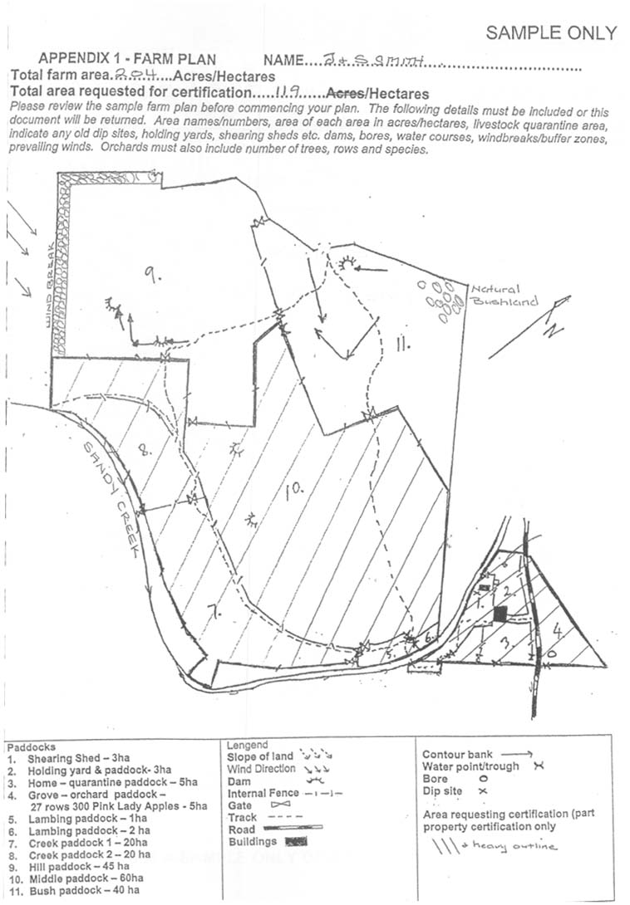

APPENDIX 2: DIRECTIONS TO PROPERTY (MUST BE COMPLETED)
Name: |  |  | Nearest Town:
This map shows directions from the nearest largest town (as stated above) to my property. Please complete in black or blue pen only, or provide computerised copy.

APPENDIX 4: LEASE AGREEMENT (TO BE COMPLETED)
LEASE AGREEMENT WITH REGARD TO CERTIFICATION

LESSOR

I;
Surname |  |  | Given Names
Address
Address 2 |  |  |  | Postcode

Telephone Number:

Being the owner of the said land Section;
Lot No |  |  |  | Area | (acres/hectares)
Hundred |  |  |  | County
Parish |  |  |  | Shire

LESSEE

The said land is leased to;

Surname |  |  | Given Names
Address
Address 2 |  |  |  | Postcode

Commencement date of lease

Term of lease

AUTHORISATION

I HEREBY AGREE:

To allow the lessee to manage the said leased area of land as required under the ‘National Standard for Organic and Biodynamic Produce’ operated by the Australian Organic Pty Ltd.

I will not personally, nor give a direction of action which may void the lessee’s certification (e.g., any use of chemicals).
Authorised by:
 | Print Full Name Clearly |  | Signature |  | Date

